Lab 2 – Dart Essentials Practice Lab

Exercise 1 – Basic Syntax & Data Types
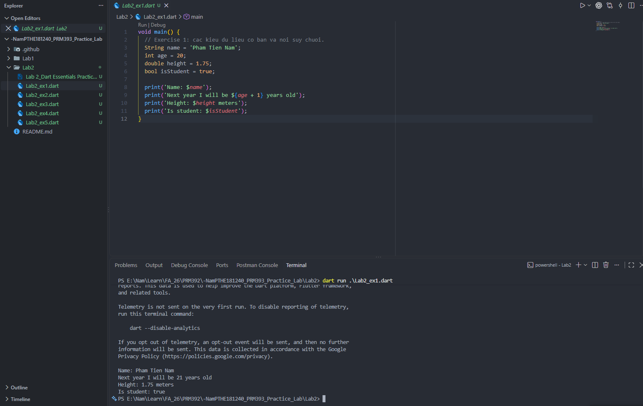
Exercise 2 – Collections & 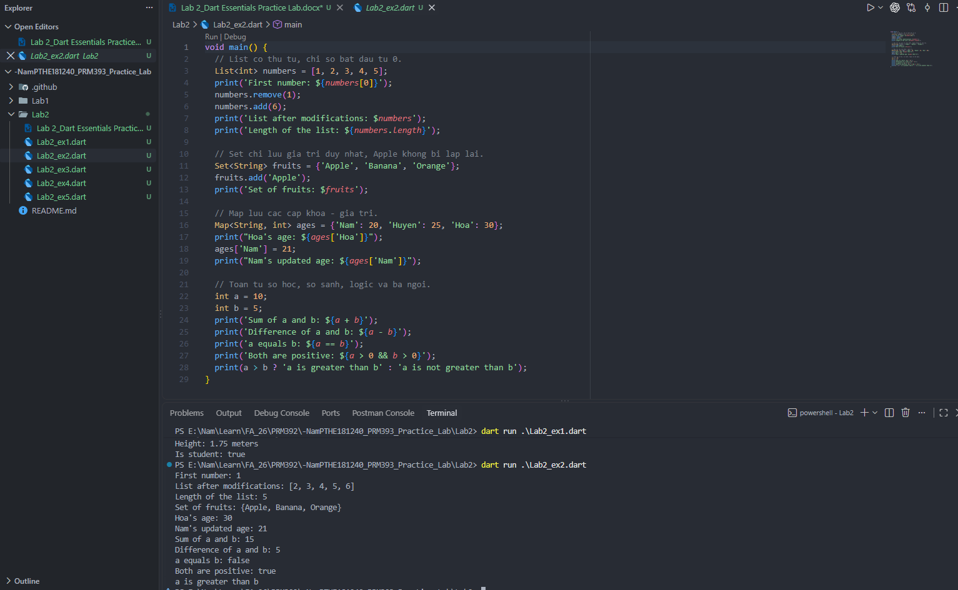
Exercise 3 – Control Flow & Functions
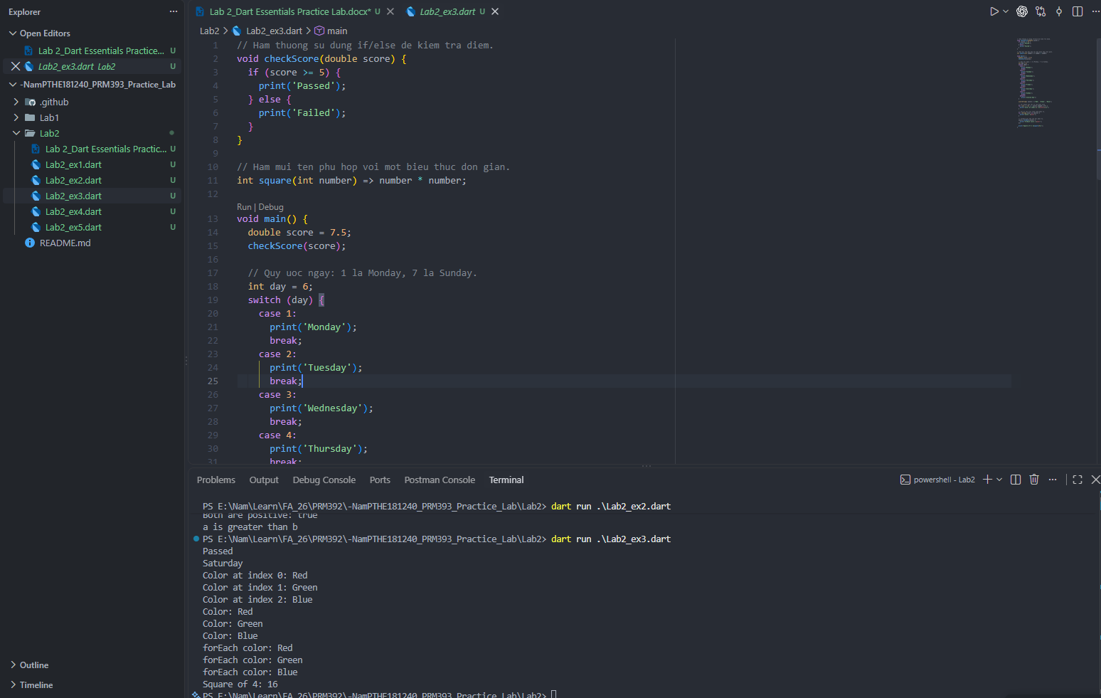
Exercise 4 – Intro to OOP
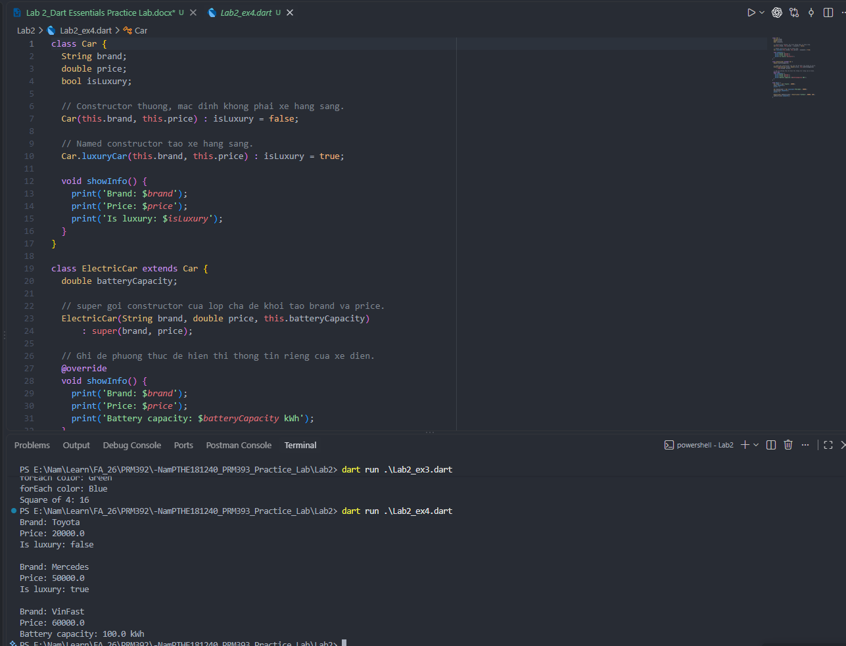
Exercise 5 – Async, Future, Null Safety & Streams
